Abstract
This project presents an On-Demand Traffic Light Control System implemented using the ATmega32 8-bit AVR microcontroller programmed in AVR Assembly language. The system controls a set of traffic signals for both vehicles and pedestrians at a simulated road intersection. Under normal operation, vehicle signals cycle through a predefined sequence: green (5 seconds), yellow (2 seconds), and red (3 seconds), while the pedestrian signal remains red.

When a pedestrian presses the push button connected to pin PD2 (INT0), an external interrupt is immediately triggered. The Interrupt Service Routine (ISR) sets a flag variable in SRAM, which causes the system to enter pedestrian mode — stopping vehicle traffic and allowing pedestrians to cross safely for 5 seconds. A blinking green signal then warns pedestrians before switching back to normal mode. The circuit was successfully simulated in SimulIDE at 16 MHz, confirming correct system behavior for all operating states.

1. Introduction

1.1 Background
Traffic management at pedestrian crossings is a critical aspect of urban infrastructure. Conventional fixed-timer traffic lights waste time by running their full cycle even when no pedestrians are waiting. Embedded systems enable a smarter approach — using interrupt-driven programming to respond instantly to pedestrian requests.

1.2 Problem Statement
Traditional traffic light systems operate on rigid fixed timing, causing unnecessary delays for pedestrians. This project solves the problem by implementing an on-demand system where pedestrians actively request a crossing signal using a push button, making the system efficient and responsive.

1.3 Scope
The project covers the design, programming (in AVR Assembly), and simulation of an on-demand traffic light system using the ATmega32 microcontroller. The simulation environment used is SimulIDE with 5 LEDs and one push button representing a real-world intersection scenario.

2. Objectives
- To design an on-demand traffic light system using the ATmega32 microcontroller
- To implement the complete program in AVR Assembly language
- To use external interrupt INT0 (PD2) for pedestrian button detection
- To simulate the hardware circuit in SimulIDE software
- To observe and verify correct LED sequencing and interrupt response
- To gain practical understanding of AVR register-level programming

3. Theoretical Background

3.1 ATmega32 Microcontroller
The ATmega32 is an 8-bit AVR RISC microcontroller with 32KB flash, 2KB SRAM, and four 8-bit I/O ports (PA, PB, PC, PD). It operates at up to 16 MHz. In this project, PORTA controls vehicle LEDs, PORTB controls pedestrian LEDs, and PD2 serves as the interrupt input. Key registers used: DDRA/DDRB/DDRD (data direction), PORTA/PORTB/PORTD (output/pull-up), MCUCR (interrupt sense), GICR (interrupt enable), SREG (status register).

3.2 AVR Assembly Language
AVR Assembly is a low-level programming language that directly maps to the ATmega32 instruction set. Key instructions used in this project include: LDI (load immediate), OUT/IN (port I/O), SBI/CBI (set/clear bit), ANDI/ORI (logical AND/OR), RJMP/RCALL/RET/RETI (jump/call/return), PUSH/POP (stack operations), DEC/BRNE (loop control), LDS/STS (SRAM access), and SEI (enable global interrupts).

3.3 External Interrupt (INT0)
The ATmega32 INT0 interrupt is connected to pin PD2. It is configured for falling edge detection by setting ISC01=1 and ISC00=0 in the MCUCR register. When the button is pressed (PD2 goes LOW), the hardware triggers ISR_INT0, saving the program counter on the stack and jumping to address 0x0002. The ISR saves SREG, sets the ped_request flag in SRAM, restores SREG, and returns with RETI.

3.4 SimulIDE Simulation Environment
SimulIDE is a real-time electronic circuit simulator that supports AVR microcontrollers including the ATmega32. It allows loading a compiled .hex firmware file and simulating the circuit with virtual LEDs, push buttons, and other components. The MCU frequency was set to 16 MHz to match the F_CPU used in delay calculations.

4. System Design

4.1 Block Diagram
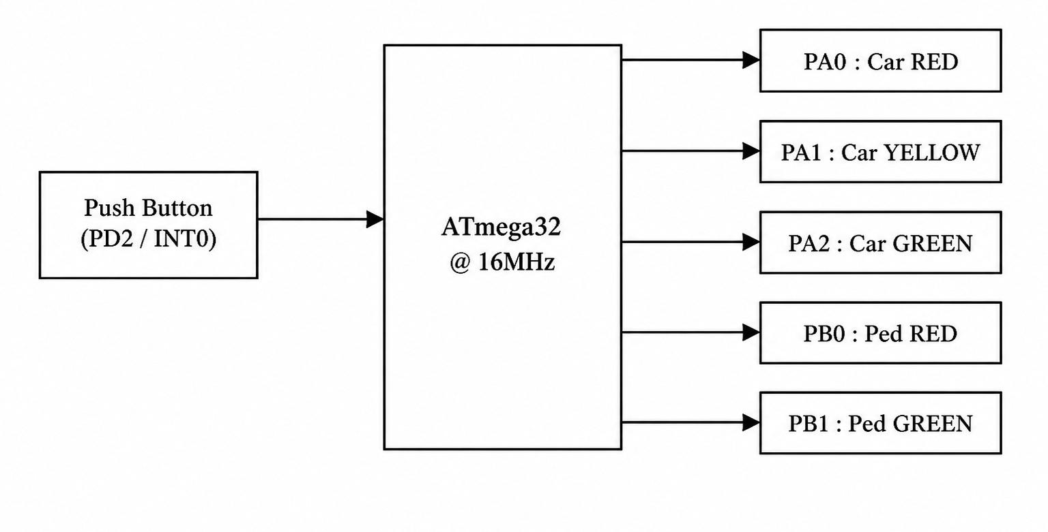

4.2 Hardware Design
Components used in the project:
Component | Qty | Purpose / Pin
ATmega32 Microcontroller | 1 | Main controller — runs Assembly firmware
Red LED | 2 | Car RED (PA0), Pedestrian RED (PB0)
Yellow LED | 1 | Car YELLOW (PA1)
Green LED | 2 | Car GREEN (PA2), Pedestrian GREEN (PB1)
330Ω Resistor | 5 | Current limiting for each LED
Push Button | 1 | Pedestrian crossing request — PD2 (INT0)
5V DC Source | 1 | Power supply connected to VCC pin

4.3 Software Design — Algorithm & Flowchart

Algorithm: On-Demand Traffic Light Control System

Start

Initialize the System

Initialize the Stack Pointer

Configure PORTA (PA0–PA2) as output for vehicle LEDs

Configure PORTB (PB0–PB1) as output for pedestrian LEDs

Configure PD2 as input (Push Button – INT0)

Enable internal pull-up resistor on PD2

Configure external interrupt INT0 for falling edge triggering

Enable global interrupts (SEI)

Initialize ped_request = 0

Set Initial State

Turn ON Car GREEN (PA2)

Turn ON Pedestrian RED (PB0)

Enter Main Loop

Check ped_request flag (SRAM)

Decision: Is ped_request == 1?

If YES:

Call PEDESTRIAN_MODE

Clear ped_request = 0

If NO:

Continue normal operation

Execute NORMAL_MODE

Turn ON Car GREEN for 5 seconds

Turn ON Car YELLOW for 2 seconds

Turn ON Car RED for 3 seconds

During each delay, check ped_request every 100 ms

If interrupt occurs, exit NORMAL_MODE immediately

Repeat Loop

Return to Step 5

End (System runs continuously in loop)

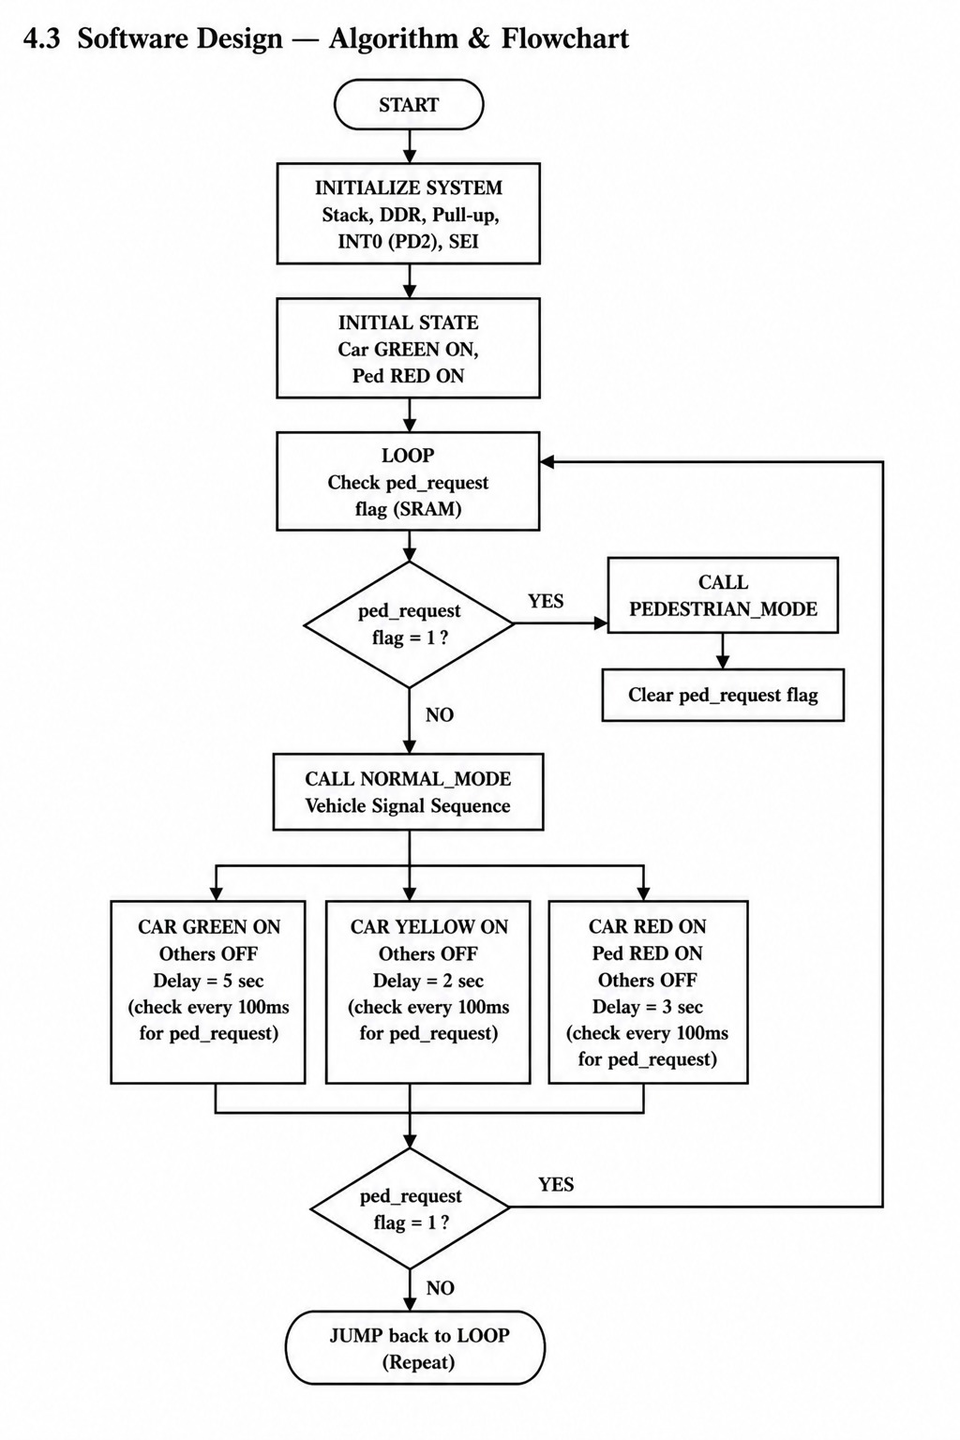

5. Circuit Diagram
The circuit was constructed in SimulIDE. The following table shows all pin connections:
MCU Pin | Component | Connection Detail
PA0 | Car RED LED | PA0 → 330Ω → Anode(+) → Cathode(−) → GND
PA1 | Car YELLOW LED | PA1 → 330Ω → Anode(+) → Cathode(−) → GND
PA2 | Car GREEN LED | PA2 → 330Ω → Anode(+) → Cathode(−) → GND
PB0 | Pedestrian RED | PB0 → 330Ω → Anode(+) → Cathode(−) → GND
PB1 | Pedestrian GREEN | PB1 → 330Ω → Anode(+) → Cathode(−) → GND
PD2 (INT0) | Push Button | PD2 → Button → GND (internal pull-up enabled)
VCC | 5V Source | VCC pin → 5V Fixed Voltage source
GND | Ground | GND pin → Ground (0V)
AVcc | Analog supply | AVcc → 5V (required by ATmega32)

6. Implementation

Step 1: Code Development in Microchip Studio
The AVR Assembly program was written in Microchip Studio by creating a new AVR Assembler project targeting the ATmega32. The .asm source file includes the m32def.inc device definition, interrupt vectors, SRAM variable declaration, full initialization routine, ISR, and all subroutines (NORMAL_MODE, PEDESTRIAN_MODE, ALL_OFF, DELAY_100MS, DELAY_300MS).

Step 2: Compilation
Build → Build Solution (F7) was executed in Microchip Studio. The assembler compiled the .asm file successfully with 0 errors and generated a .hex firmware file in the project's Debug folder.

Step 3: Circuit Construction in SimulIDE
The ATmega32 was placed in SimulIDE. Five LEDs with 330Ω resistors were connected to the correct ports (PORTA and PORTB). A push button was connected from PD2 to GND. A 5V Fixed Voltage source was connected to the VCC pin. The MCU frequency was set to 16 MHz in Properties.

Step 4: Firmware Loading
The ATmega32 Properties window was opened in SimulIDE. The .hex file path was entered in the Firmware field. The option 'Reload hex at Simulation Start' was enabled for convenience.

Step 5: Simulation and Verification
The Play button was pressed to start simulation. The traffic light sequence was observed and verified. The push button was clicked to test pedestrian mode. All behaviors matched the expected design.

7. Code — AVR Assembly (main.asm)
Complete AVR Assembly program with comments:

; ============================================================
; On-Demand Traffic Light Control - ATmega32 Assembly
; PIN: PA0=Car RED, PA1=Car YELLOW, PA2=Car GREEN
; PB0=Ped RED, PB1=Ped GREEN, PD2=Button (INT0)
; ============================================================
.include "m32def.inc"

.equ CAR_RED = 0 ; PA0
.equ CAR_YELLOW = 1 ; PA1
.equ CAR_GREEN = 2 ; PA2
.equ PED_RED = 0 ; PB0
.equ PED_GREEN = 1 ; PB1

.dseg
ped_request: .byte 1 ; 0=no request, 1=button pressed

.cseg
.org 0x0000
rjmp MAIN ; Reset vector
.org 0x0002
rjmp ISR_INT0 ; INT0 interrupt vector

; --- ISR: Button Press (INT0) ---
ISR_INT0:
push r16
in r16, SREG
push r16
ldi r16, 0x01
sts ped_request, r16 ; Set flag
pop r16
out SREG, r16
pop r16
reti

; --- MAIN: Initialization ---
MAIN:
ldi r16, low(RAMEND)
out SPL, r16
ldi r16, high(RAMEND)
out SPH, r16
ldi r16, 0x07 ; PA0-PA2 output
out DDRA, r16
ldi r16, 0x03 ; PB0-PB1 output
out DDRB, r16
in r16, DDRD
andi r16, 0xFB ; PD2 input
out DDRD, r16
in r16, PORTD
ori r16, 0x04 ; PD2 pull-up on
out PORTD, r16
in r16, MCUCR
ori r16, 0x02 ; ISC01=1 (falling edge)
andi r16, 0xFE ; ISC00=0
out MCUCR, r16
in r16, GICR
ori r16, 0x40 ; INT0 enable
out GICR, r16
ldi r16, 0x00
sts ped_request, r16 ; Clear flag
sei ; Global interrupt enable
sbi PORTB, 0 ; Ped RED on
sbi PORTA, 2 ; Car GREEN on

; --- MAIN LOOP ---
LOOP:
lds r16, ped_request
cpi r16, 0x01
brne SKIP_PED
ldi r16, 0x00
sts ped_request, r16
rcall PEDESTRIAN_MODE
SKIP_PED:
rcall NORMAL_MODE
rjmp LOOP

; --- ALL_OFF: Turn off all LEDs ---
ALL_OFF:
in r16, PORTA
andi r16, 0xF8 ; PA0,PA1,PA2 off
out PORTA, r16
in r16, PORTB
andi r16, 0xFC ; PB0,PB1 off
out PORTB, r16
ret

; --- PEDESTRIAN MODE ---
PEDESTRIAN_MODE:
rcall ALL_OFF
sbi PORTA, 0 ; Car RED on
sbi PORTB, 1 ; Ped GREEN on
cbi PORTB, 0 ; Ped RED off
ldi r20, 50 ; 5 seconds wait
PED_WAIT:
rcall DELAY_100MS
dec r20
brne PED_WAIT
ldi r20, 4 ; Blink 4 times
BLINK_LOOP:
in r16, PORTB
ldi r17, 0x02
eor r16, r17 ; Toggle PB1
out PORTB, r16
rcall DELAY_300MS
dec r20
brne BLINK_LOOP
rcall ALL_OFF
sbi PORTB, 0 ; Ped RED on
ret

; --- NORMAL MODE: GREEN->YELLOW->RED ---
NORMAL_MODE:
rcall ALL_OFF
sbi PORTB, 0 ; Ped RED on
sbi PORTA, 2 ; Car GREEN on
ldi r20, 50 ; 5 seconds
GREEN_LOOP:
rcall DELAY_100MS
lds r16, ped_request
cpi r16, 1
breq NORMAL_EXIT ; Exit if button pressed
dec r20
brne GREEN_LOOP
rcall ALL_OFF
sbi PORTB, 0
sbi PORTA, 1 ; Car YELLOW on
ldi r20, 20 ; 2 seconds
YELLOW_LOOP:
rcall DELAY_100MS
lds r16, ped_request
cpi r16, 1
breq NORMAL_EXIT
dec r20
brne YELLOW_LOOP
rcall ALL_OFF
sbi PORTB, 0
sbi PORTA, 0 ; Car RED on
ldi r20, 30 ; 3 seconds
RED_LOOP:
rcall DELAY_100MS
lds r16, ped_request
cpi r16, 1
breq NORMAL_EXIT
dec r20
brne RED_LOOP
NORMAL_EXIT:
ret

; --- DELAY_100MS @ 16MHz ---
DELAY_100MS:
ldi r24, 21
D100_OUTER:
ldi r25, 238
D100_INNER:
ldi r26, 160
D100_INNER2:
dec r26
brne D100_INNER2
dec r25
brne D100_INNER
dec r24
brne D100_OUTER
ret

; --- DELAY_300MS = 3 x DELAY_100MS ---
DELAY_300MS:
rcall DELAY_100MS
rcall DELAY_100MS
rcall DELAY_100MS
ret

8. Results & Observations
The simulation confirmed correct operation of all modes. The following screenshots show different operating states captured during simulation:

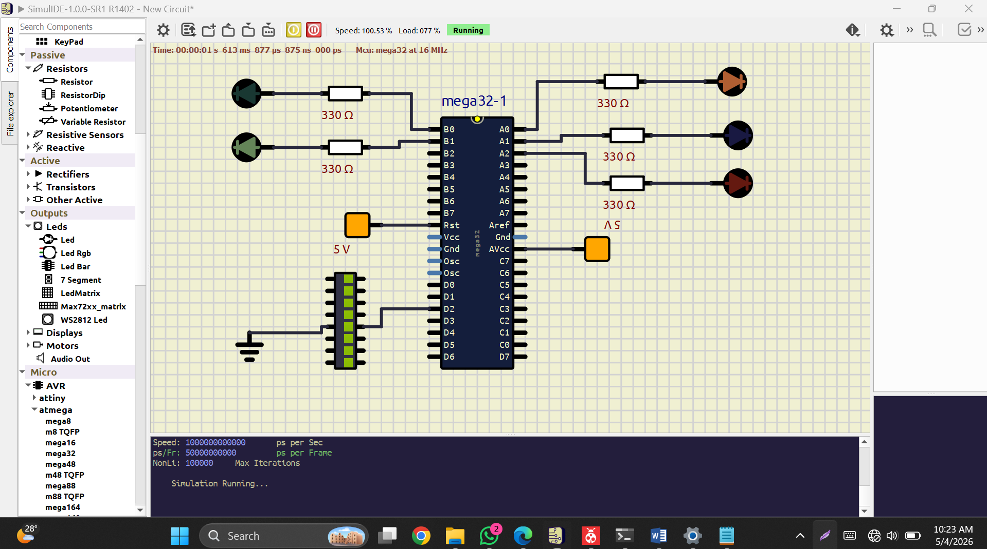
Figure x: Pedestrian mode activated — Car RED on (PA0), Pedestrian GREEN on (PB1), indicating safe crossing for pedestrians. Simulation time: 1s 613ms.

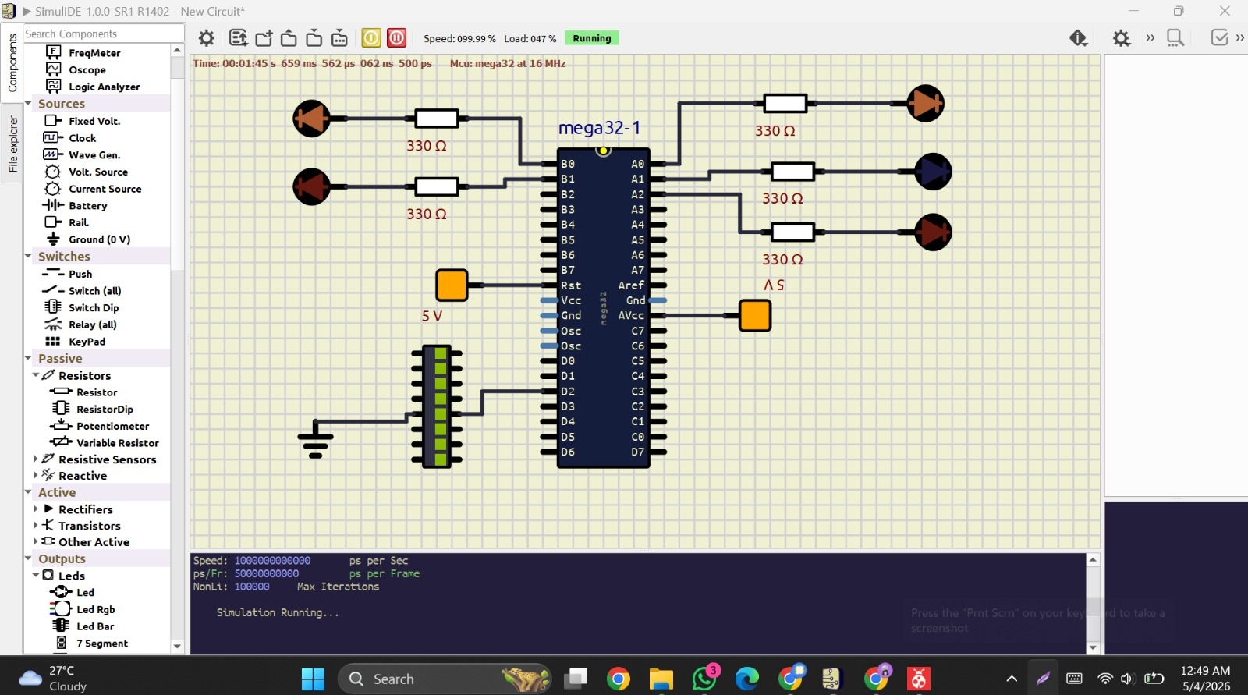
Figure 1: Car RED + Pedestrian RED — Initial/Pedestrian mode (Time: 1m 45s)

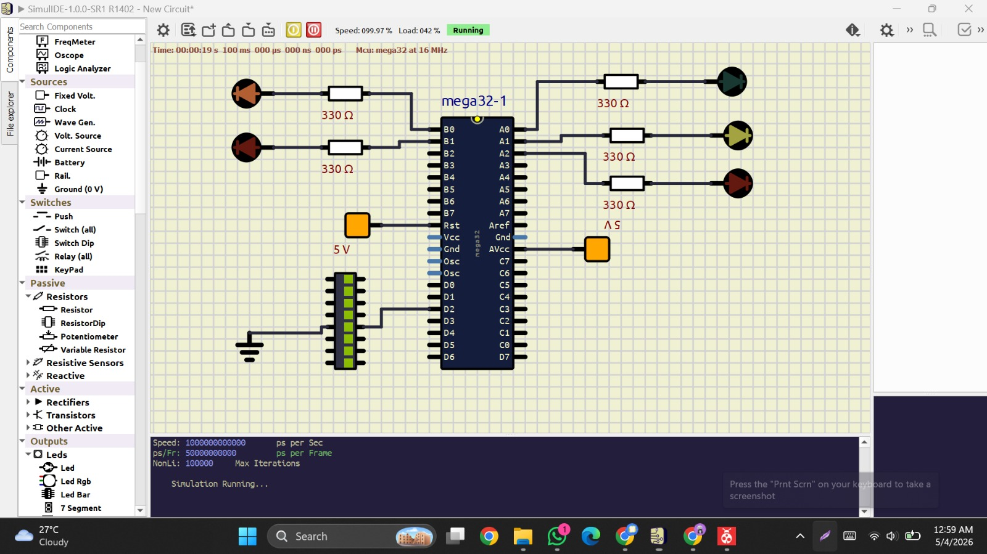
Figure 2: Car GREEN on, Pedestrian RED — Normal mode GREEN phase (Time: 19s)

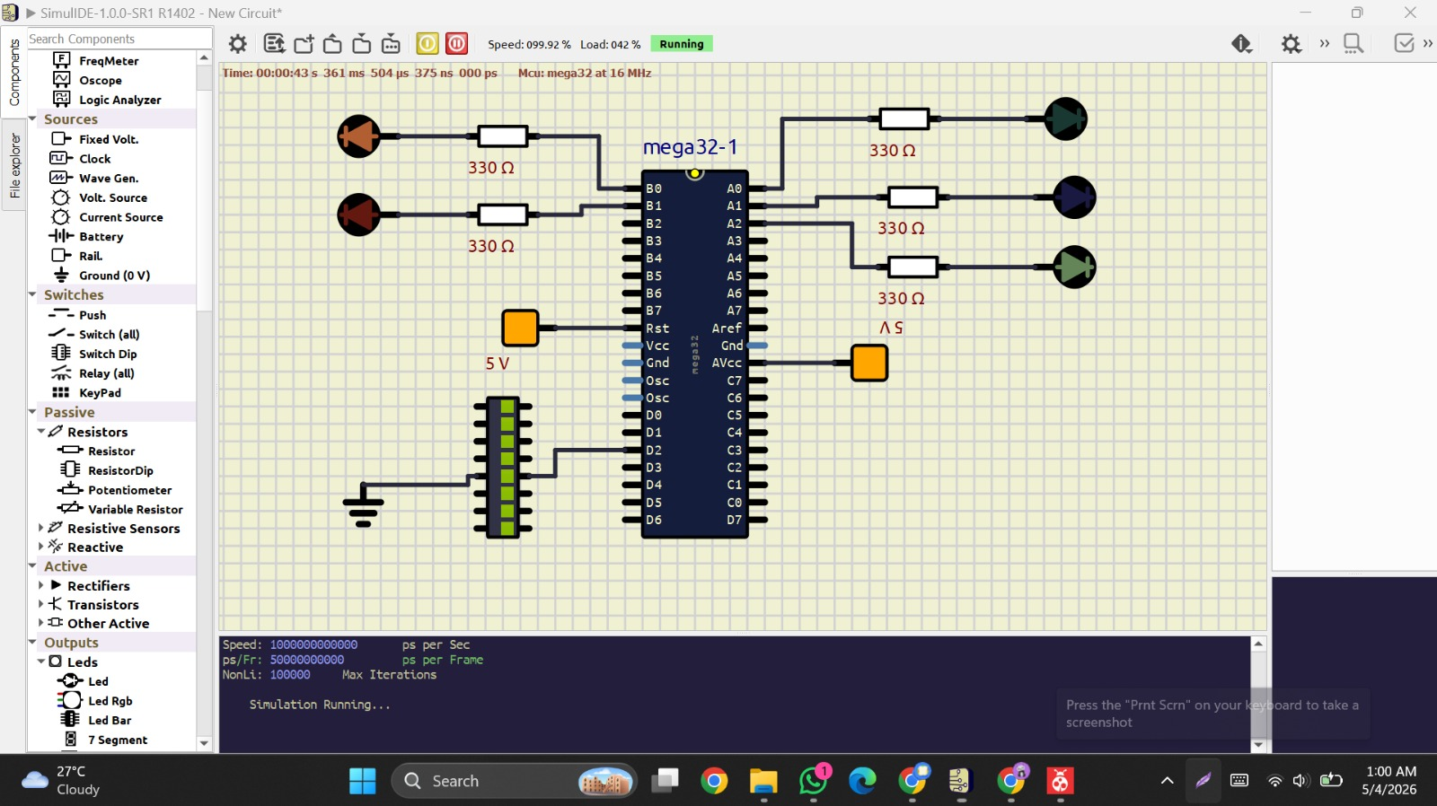
Figure 3: Car GREEN → Pedestrian GREEN transition — Pedestrian mode activated (Time: 43s)

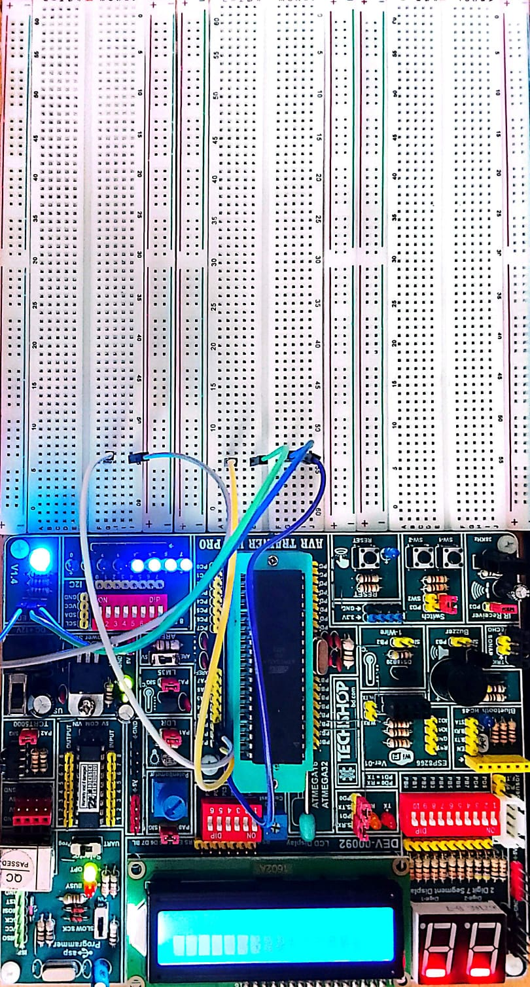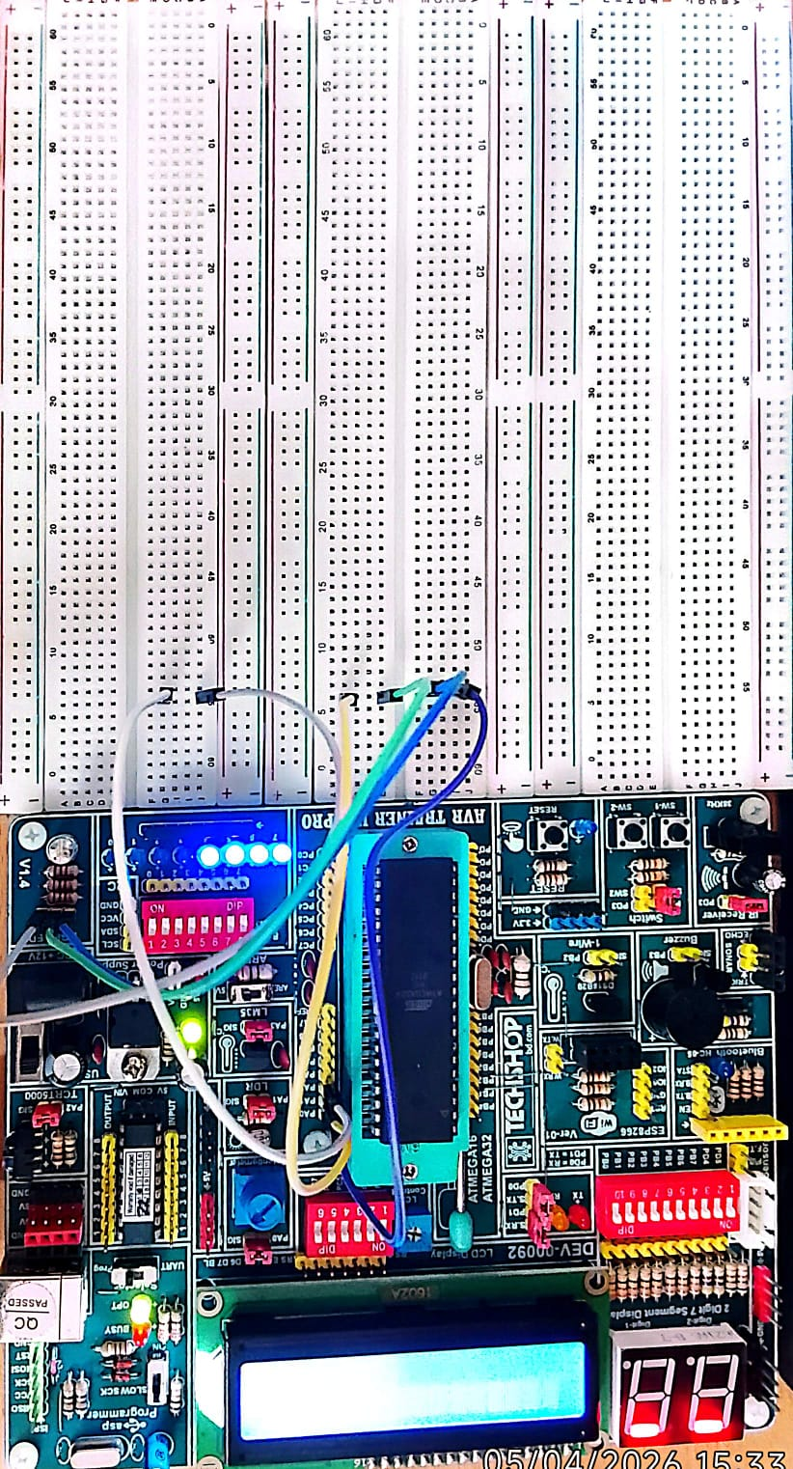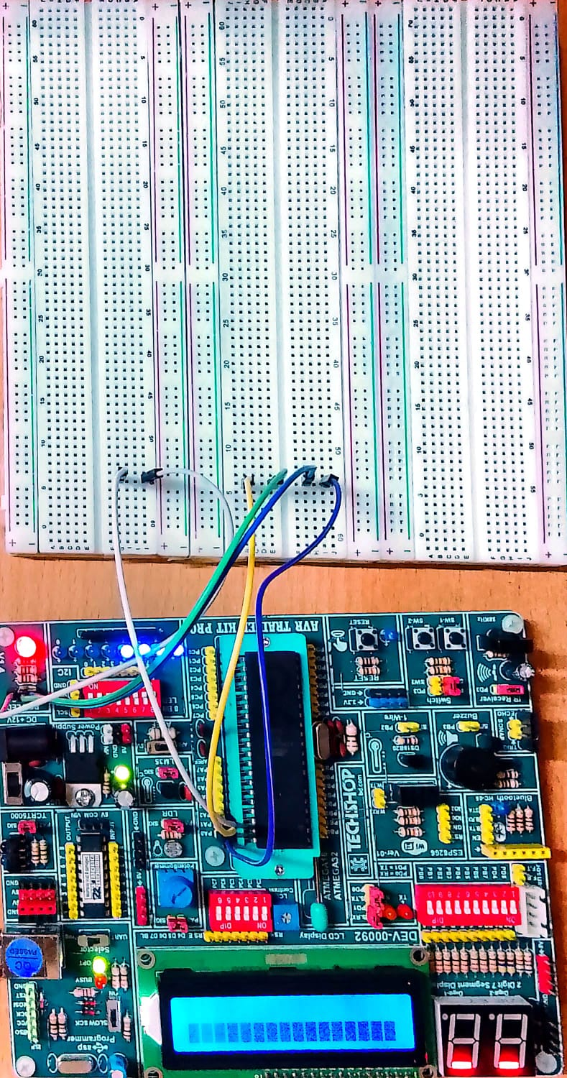

Figure 4: Hardware Simulation
Observation table:
State | Duration | LED Status
Car GREEN (Normal) | 5 seconds | PA2 HIGH, PB0 HIGH — Cars move, Ped stopped
Car YELLOW (Normal) | 2 seconds | PA1 HIGH, PB0 HIGH — Cars slowing
Car RED (Normal) | 3 seconds | PA0 HIGH, PB0 HIGH — Cars stopped
Pedestrian Mode | 5 seconds | PA0 HIGH, PB1 HIGH — Cars stopped, Ped crosses
Ped GREEN blink | ~1.2 seconds | PB1 blinks 4× (300ms each) as warning
Button press response | Immediate (ISR) | ped_request=1 set, mode changes at next loop check

9. Discussion

9.1 Challenges Faced
- Configuring INT0 correctly required understanding MCUCR register bit fields (ISC01, ISC00) at the assembly level
- Saving and restoring SREG inside the ISR was critical to avoid corrupting arithmetic flags used by the main program
- Connecting LED anode and cathode in the correct orientation in SimulIDE required careful attention
- Delay calibration for 16 MHz required calculating correct loop iteration counts for 100ms timing
- AVcc pin connection was necessary to prevent ATmega32 from malfunctioning in SimulIDE

9.2 Limitations
- Fixed timing does not adapt to actual traffic density
- No debounce logic implemented for the push button
- Only one pedestrian crossing direction is handled
- The system does not support multiple simultaneous pedestrian requests

10. Applications
- Pedestrian crossing signals at road intersections and school zones
- Hospital and emergency zone traffic management
- Smart traffic systems as a foundation for IoT-based solutions
- Educational tool for learning interrupt-driven embedded systems design
- Prototype for low-cost traffic control in developing urban areas

11. Conclusion
This project successfully implemented an on-demand traffic light control system using the ATmega32 microcontroller programmed entirely in AVR Assembly language. The system demonstrated correct interrupt-driven behavior — immediately responding to pedestrian button presses while maintaining a smooth normal traffic sequence. The simulation in SimulIDE at 16 MHz confirmed all expected operating states including normal mode (Green → Yellow → Red cycling), pedestrian mode activation, and the blinking warning before returning to normal operation.
The project provided hands-on experience with low-level register programming, ISR design, SRAM variable usage, and hardware simulation — all fundamental skills in embedded systems engineering.

12. Future Work

This project provides a basic implementation of an on-demand traffic light system, but several improvements can enhance its performance and practicality. The following enhancements are suggested:
- Add debounce logic to avoid false button triggers
- Use hardware timers instead of software delays for better accuracy
- Extend to multiple intersections with coordinated signals
- Use IR/ultrasonic sensors for adaptive traffic control
- Add an LCD display for countdown indication
- Implement on real hardware and enable wireless monitoring

13. References
- Microchip Technology. ATmega32 Datasheet. Available: https://www.microchip.com/en-us/product/ATmega32
- AVR Instruction Set Manual. Microchip Technology Inc.
- Microchip Studio (AVR Studio 7) — IDE for AVR Assembly
- SimulIDE Real-Time Simulator. Available: https://simulide.com

